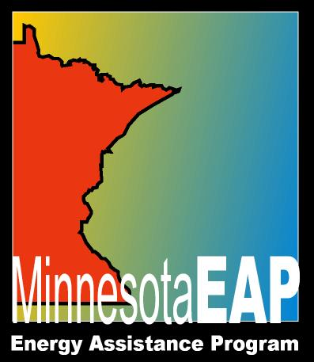
Template for Garnishment Response Letter

This sample letter is provided to help Service Providers respond to garnishment information requests.
Service Provider Name
SP Mailing Address
City, MN 99999-9999
Phone: (999) 999-9999
TTY: (999)999-9999
July 30, 2026

<<Requestor & requestor address>>

RE: << Name>>
To Whom It May Concern:

This is to verify <<Name >> was approved for and is a current recipient of assistance from the Energy Assistance Program (EAP).

Households are considered eligible for EAP relief based on need through the end of the program year, which is September 30.

The household may reapply on October 1 for the next program year.

See Minnesota Statutes 2010, 571.27.

If you have any further questions you can contact me at <<Coordinator phone number>>.

Sincerely,

Energy Assistance Coordinator

